CamTest TOF Viewer User Guide

Version

0.1.0.0

Table Of Contents:

1. Introduction

About CamTest TOF Viewer

Keyword definition

2. Getting started

Start CamTest

CamTest main screen

Device list Zone

Camera Zone

Information Zone

Message Zone

3. Operations

Module mode

Color mode

Depth mode

Camera mode

Property Page

Maintain Page

Register Page

TOF decode option

Version Information

Report bugs

Chapter 1: Introduction:

This user guide provided key term definition and usage guide on using CamTest software. The CamTest software is for viewing, configuring, accessing TOF module data.

Bug report & Tracking:

https://github.com/lxnick/CamTest/issues

About CamTest TOF Viewer

The CamTest TOF view provide user interface to TOF module, with capability of viewing/configuring TOF module, and capturing TOF data.

Keyword definition

The TOF module contains 2 cameras, for better understanding this document, these terms were defined.

Module:

Module was defined as whole module, with both color camera and depth camera. To enable the module mode, both cameras should be connected to USB hub which has sufficient power supply, before launching the CamTest software.

Color Camera:

Color camera is the color camera on the module, which provides the similar view of the TOF sensor.

Depth Camera:

Depth camera includes the TOF (depth) information. The display is made from depth information instead of image information.

Camera:

Cameras not belong to TOF modules was simply name Camera. They are not well supported.

Chapter 2: Getting started

Before start the CamTest software, make sure TOF module was attached on computer and powered.

<To Do> Add device manager thumbnail

Double click the CamTest.exe to launch the CamTest.

CamTest main screen

The main screen of CamTest was shown in Fig 1. The left of the screen is the Device List Zone. The middle is the Camera Zone, the right is the Information Zone, and below is the Message Zone.

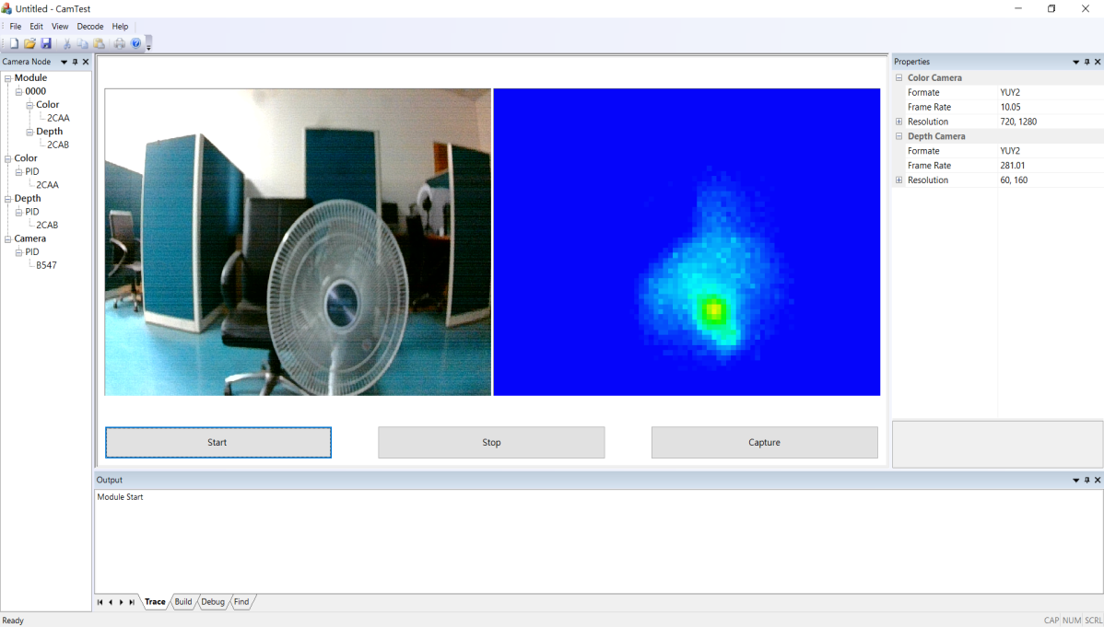

Device list Zone

The Device List Zone lists the devices (cameras) attaches on the computer. CamTest did not support hot-plug. If the device (camera) was not listed, the device (camera) was not enumerated properly. Please check if the connection, then re-launch the program.

There are 4 catalogs in the Device List Zone. Refer to Key-definition section in introduction. Devices found in program startup are all listed in proper catalog with their PID. Refer to Fig 2. There are 1 Module (index 0000) attached on the computer. The Module contains 1 Color Camera (PID 2CAA) 1 Depth Camera (PID2CAB). The Color Camera contains 1 item, which is same as the Color Camera of Module. It was listed separated for accessing individually. There is also an item in the Depth Camera (PID 0CAB) which was from Module, similarly. The Camera with (PID B547) is a webcam attached on the computer. This Catalog was for debugging and reference only.

Click the id or PID to switch the modes.

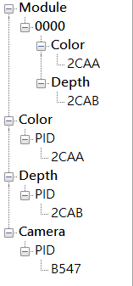

Camera Zone

Camera Zone provides image live display, and operations to be done with proper Module/Color/Depth/Camera. For different catalog, the display is different. Below is the display for Module. The left displays the live show from Color, the right show the Depth, the buttons represent the actions were below the displays.

For different catalog, the available buttons were also different.

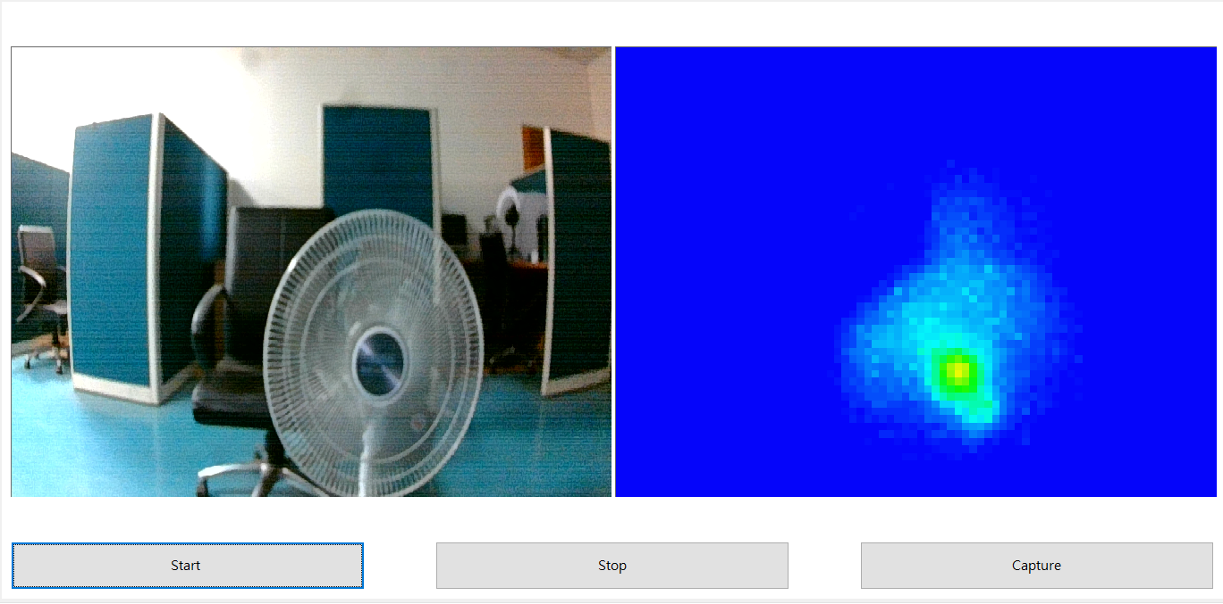

Information Zone

Information zone displays the video information, such as video format, frame rate, video resolution. If Module is running, both Color Camera and Depth Camera video information was displayed. Otherwise, only running camera’s information was displayed.

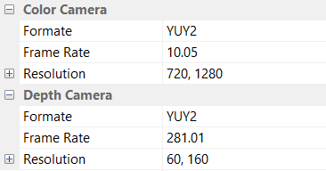

Message Zone

Message and indication was display in Message Zone. When issue capturing, full file path to the captured files were displayed.

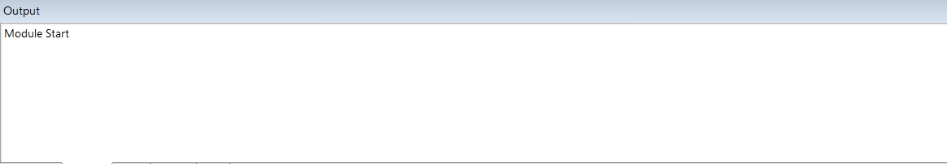

Chapter 3: Operations

Here, we describe the operations can be done in various modes.

Module mode

At Module mode, these buttons can be clicked

Start

Start live view of Color & Depth Camera, video information will be displayed in Information Zone

Stop

Stop the live view. Sometimes, switching mode without stop will cause program crashed. The problem will be fixed. Before the problem fixed, click stop before switching mode will be safer.

Capture

Capture the Color (image file) and Depth (depth data), and save to local file. The full file path will be displayed in Message Zone.

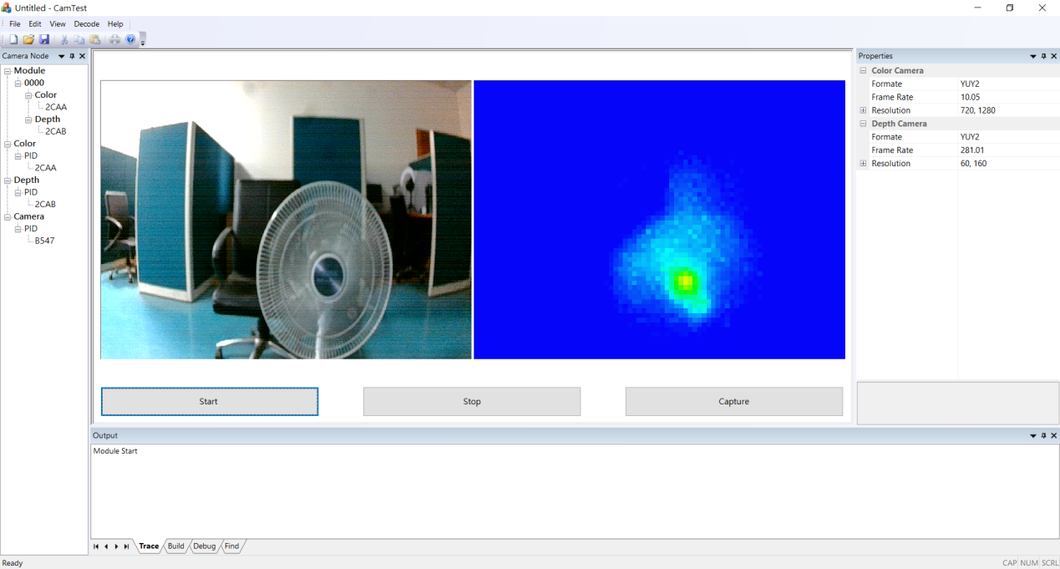

Color mode

The Color mode and Camera mode are the same. They provide:

Start

Start live view of Color Camera, video information will be displayed in Information Zone

Stop

Stop the live view. Sometimes, switching mode without stop will cause program crashed. The problem will be fixed. Before the problem fixed, click stop before switching mode will be safer.

Property

Launch Property dialog, which provide control to the video. For further information, check Property Page.

Capture

Capture the Color (image file), and save to local file. The full file path will be displayed in Message Zone.

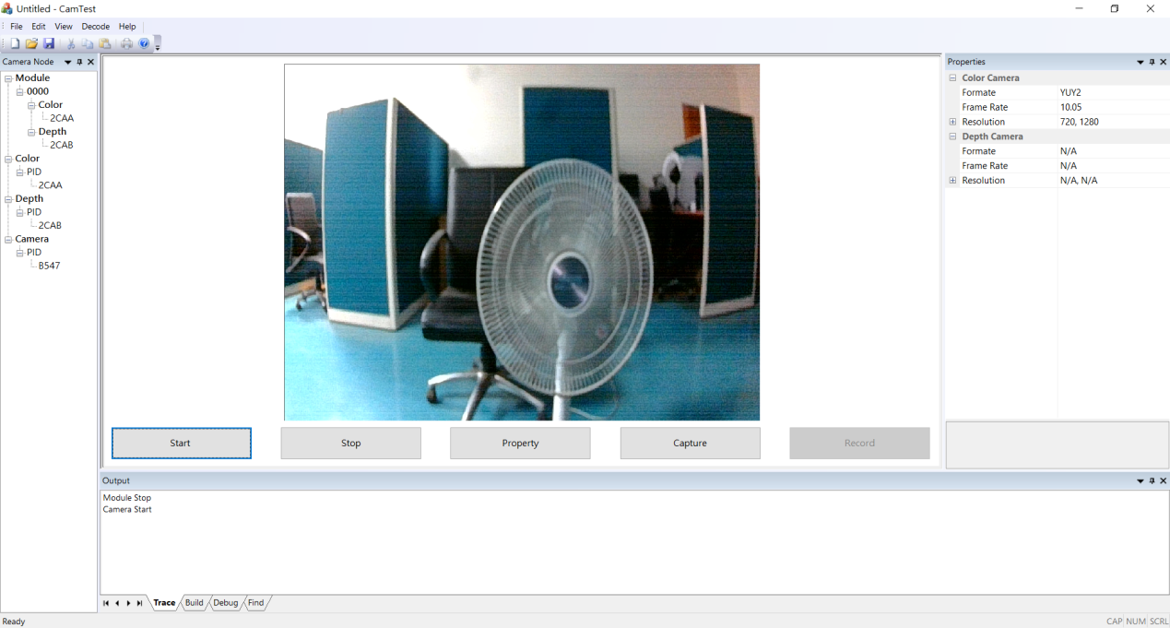

Depth mode

The Depth mode provide live view and control to the Depth Camera:

Start

Start live view of Depth Camera, video information will be displayed in Information Zone

Stop

Stop the live view. Sometimes, switching mode without stop will cause program crashed. The problem will be fixed. Before the problem fixed, click stop before switching mode will be safer.

Property

Launch Property dialog, which provide control to the video. For further information, check Property Page.

Maintain

Provide low level operation to the Depth Camera. Reference Maintain Page

Register

Provide register read/write to the TOF sensor. Reference the Register Page.

Capture

Capture the Depth (binary data), and save to local file. The full file path will be displayed in Message Zone.

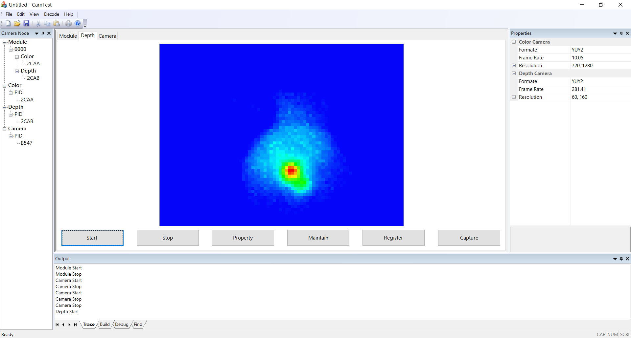

Camera mode

Camera mode is same as Color mode, for now.

Property Page

Property Page provide video control to the cameras (Color & Depth)

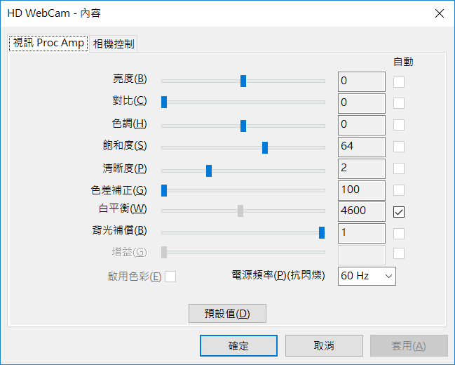

Maintain Page

Maintain Page provide low level control to the Depth Camera. Incorrect operation may cause Module bricking. Be careful.

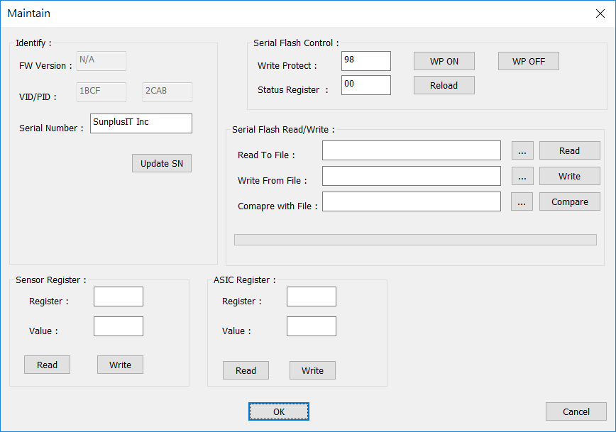

Register Page

Access TOF senor registers.

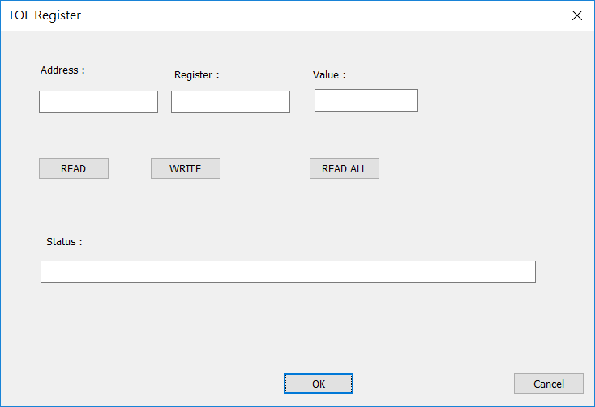

TOF decode option

For various firmware version may have different coding, there are decode options in the menu.

From the menu “TOF decode”, there are 3 options:

DeAliase, Group, RAW.

If the option RAW was checked, CamTest will not do any decode/process, just bypass the binary data to display, it will looks like below.

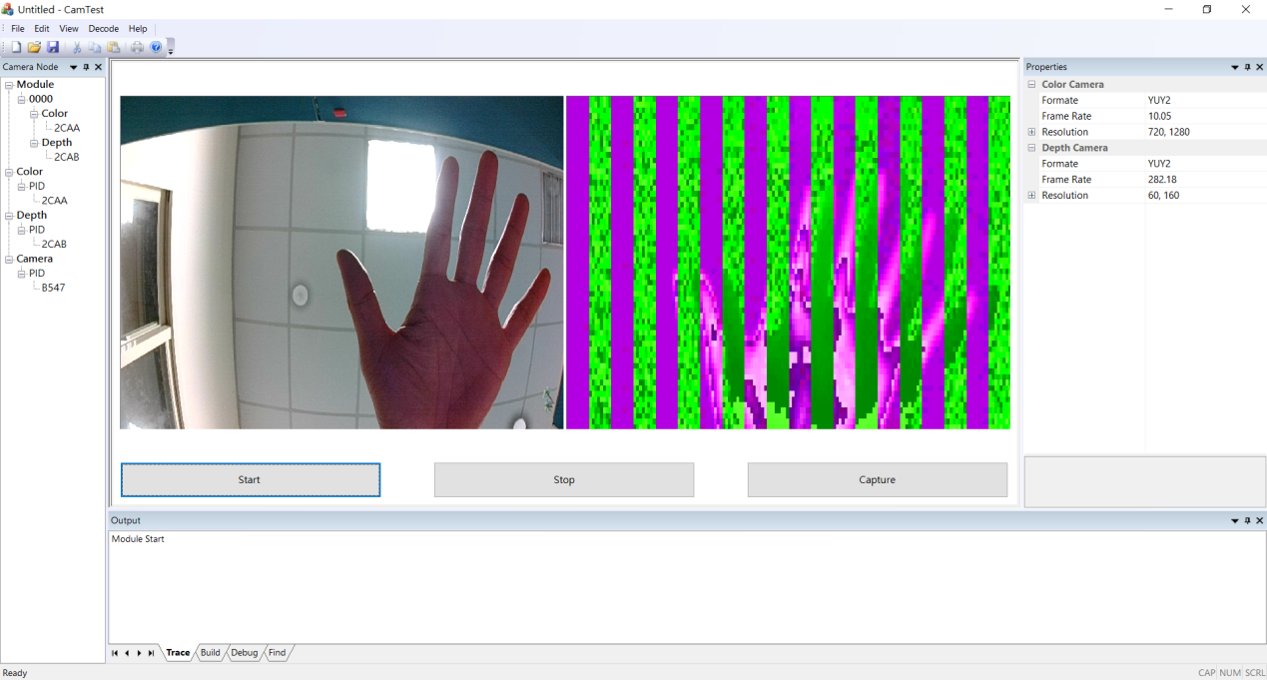

For FW TOF_20170419.bin, the correct option is

        (V) DeAliase

        (_) Group

        (_) RAW

For FW TOF_20170512.bin, the correct option is

        (V) DeAliase

        (V) Group

        (_) RAW

Version Information

Right click the CamTest.exe icon, then select the “details”, will display version information.

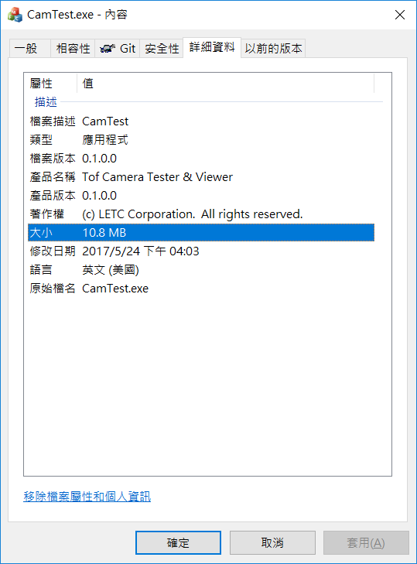

Report bugs

When bug encountered, please issue at below.

<https://github.com/lxnick/CamTest/issues>

Click the green button “New issue” to create new issue.

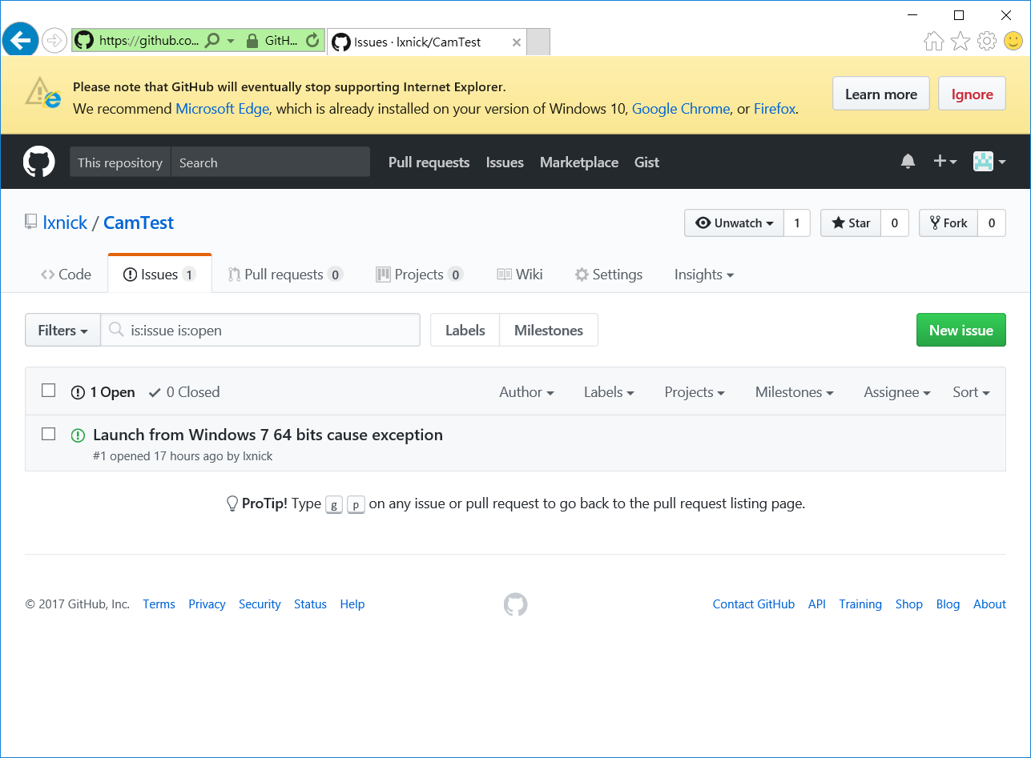

Please also attach the log file. The log file was saved in LOG sub folder in the same folder of the CamTest. CamTest will auto create it if not exist. The file was named as CameraTest-YYYY-MM-DD-HH-mm.txt, Y (Year), M(month), D(day), H(Hour), m(minute). Please send only the log with problems.

The bug tracking system did not support txt file, so please compressed it into zip. We will try some other methods to make it easy.

System (Computer) information was auto collected, so no more information about the computer needs to be described.

